Tab 1



Software Engineering Department

Braude College

Nimbus - Capstone Project Phase A  
Production Line Augmented Reality Application

By:  
Shlomi Fridman  
Shahar Berenson

Advisor:  
Dr. Naomi Unkelos Shpigel

Project Code:   
25-2-D-9

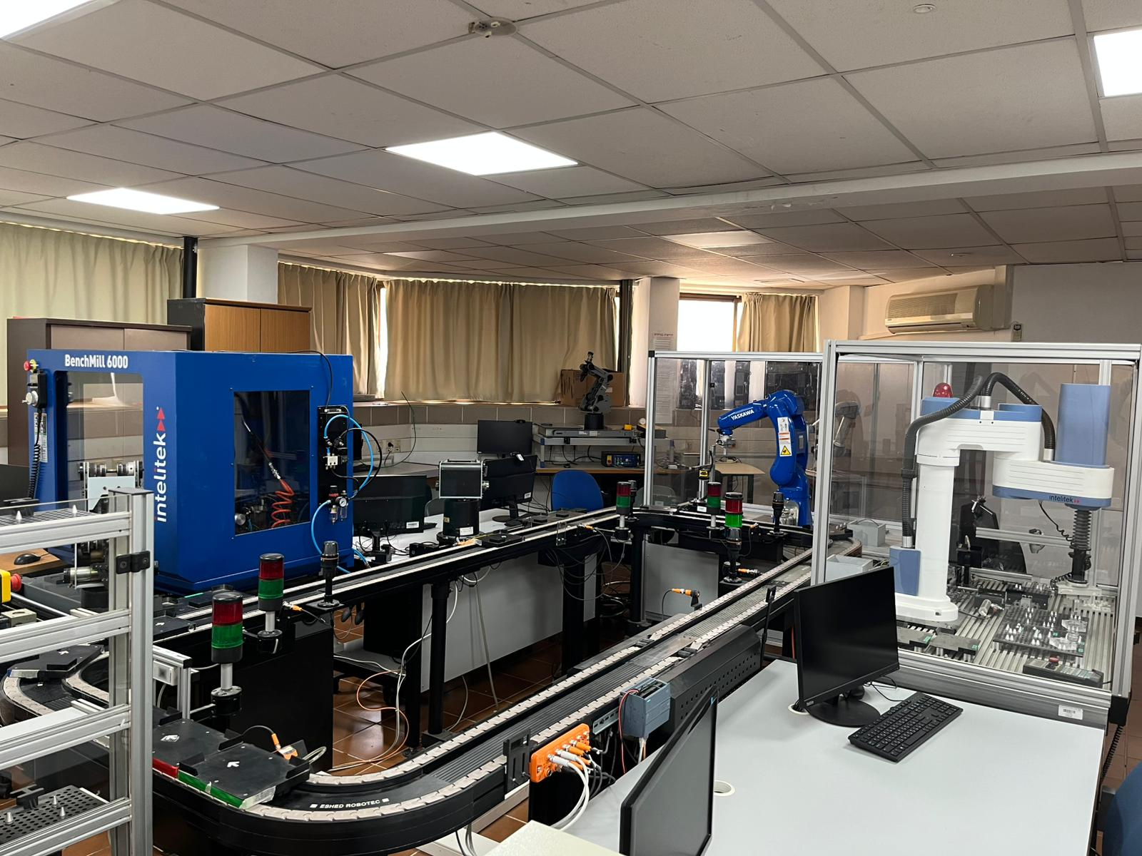

[Github](https://github.com/ShlomiFridman/BraudeProject2025)

[Google Drive](https://drive.google.com/drive/folders/1d9d7qySiWZ9NJXprHCEOfVBDN4EBlcE3?usp=sharing)

Table of Contents

**Common Definitions and Acronyms 2**

**Abstract 2**

**1. Introduction 3**

**2. Background and Related Works 4**

2.1 - Augmented Reality For Monitoring 4

2.2 - The Industrial Internet of Things (IIoT) 4

2.3 - Augmented Reality For IIoT 4

2.4 - Lab D106 Production Line 6

**3. Engineering Process 10**

3.1 - Timeline 10

3.3 - Interviews 11

3.4 - Software and Platforms Used in Development 11

**4. Product details 14**

4.1 Product Scope 14

4.2 Product Value 14

4.3 Intended Audience 14

4.4 Intended Use 14

4.5 General Description 14

4.6 Functional Requirements 15

4.7 External Interface Requirements 16

4.8 Non-Functional Requirements 19

**5. Diagrams 20**

5.1 - Architecture Diagram 20

5.2 - Use Case Diagram 21

5.3 - Sensor Data Sequence Diagram 22

5.4 - Class Diagram 23

5.5 - QR-Code Sensor Flowchart 25

5.6 - IMU Sensor Flowchart 25

**6. Evaluation / Verification Plan 27**

6.1 - Expected Achievements 27

6.2 - KPI Metrics 28

6.3 - Prototype 29

**References 32**

**Appendix 34**

# Common Definitions and Acronyms

| **Term** | **Description** |
| --- | --- |
| AR | Augmented Reality |
| DT | Digital Twin |
| IMU | Inertial Measurement Unit |
| (N)FR | (Non-)Functional Requirement |
| QR-CODE | Quick-Response Code |
| StationEnum | Predefined enum representing stations in the production line |

# Abstract

Understanding and monitoring production line operations remains a challenge for engineering students and educational staff alike, due to the complexity and abstraction of traditional tools. To address this, we designed a mobile Augmented Reality (AR) application that visualizes a real production line using Unity, integrating real-time data from QR-Code and IMU sensors installed on the line. The system enables users to interact with digital twins of physical stations, track cart movement, and receive visual feedback, thereby enhancing both educational engagement and operational monitoring.The project presents the design and development of a mobile Augmented Reality (AR) application aimed at enhancing educational engagement and operational monitoring within a production line environment. Developed as part of a capstone project at Braude College, the system utilizes the Unity Engine and integrates real-time data collected from QR-Code Readers and Inertial Measurement Unit (IMU) sensors installed on a physical production line located at Lab D106. The AR application enables students and lecturers to interact with digital representations of the physical stations, track cart movements, and receive visual feedback including text, images, and videos. By combining AR with the Industrial Internet of Things (IIoT), this project seeks to transform traditional engineering education into a more immersive, interactive, and intuitive learning experience.

**Keywords:**Production Line Training, AR Instructional Guide, Engineering Education, Digital Twin (DT), Industrial Internet of Things (IIoT)

# 

# 1. Introduction

In modern industrial and educational settings, understanding and visualizing production line operations can be a complex task. Traditional monitoring systems often rely on static dashboards and abstract representations, which may limit comprehension, especially for students and trainees unfamiliar with the underlying processes. This gap is particularly evident in engineering education, where hands-on experience and real-time feedback are critical for grasping system behavior and production dynamics. Moreover, in an era driven by the Industrial Internet of Things (IIoT), there remains a challenge in making this sensor-driven data accessible and meaningful to users in an intuitive format [Peter 2023] [Shabur 2024].

AR, when paired with IIoT, offers significant potential in delivering real-time, contextual data that improves user interaction and decision-making [Liberty 2024] [Bucsai 2020]. A study by [Al-Ansi 2023], employing text mining and topic analysis, concluded that AR and Virtual Reality (VR) technologies have seen exponential growth in educational settings, enhancing immersive learning experiences. A study [Lin 2024] examined the implementation of AR in dental surgery education and clinical practice, finding that such technologies provide immersive simulations that significantly enhance the retention of surgical skills. Nevertheless, challenges such as high implementation costs and integration complexities continue to impede widespread adoption.

Leveraging AR’s ability to overlay digital content onto physical environments, we designed a mobile application built with the Unity Engine and powered by Vuforia. This application offers users—especially lecturers and students—a dynamic and immersive visualization of a functioning production line. Real-time data from QR-Code sensors and speed monitors is processed by a backend server and delivered to the AR interface, enabling users to track the location, status, and movement of carts across multiple stations. Descriptive media such as text, images, and videos enrich the user experience [Syed 2022] [Fuentes 2024], turning technical information into an engaging and educational tool.

The project aims to not only enhance production line transparency and provide monitoring services but also bridge the gap between industrial operations and educational training through an accessible, immersive AR experience.

# 2. Background and Related Works

## 2.1 - Augmented Reality For Monitoring

Augmented Reality (AR) has emerged as a powerful tool for monitoring systems, enabling real-time visualization of data and enhancing decision-making processes. In the field of industrial monitoring, AR allows for the integration of digital information into physical environments, facilitating the monitoring of equipment status and operational performance. For example, AR applications can provide technicians with real-time maintenance data by overlaying sensor data onto the physical machinery, helping in fault detection and predictive maintenance [Syed 2022]. Additionally, AR systems can enhance remote collaboration, allowing experts to assist on-site personnel by visualizing the system's status through wearable AR devices [Pavanatto 2021]. This immersive approach to monitoring is not only improving operational efficiency but also reducing downtime and costs associated with manual inspections [Li 2024].

## 2.2 - The Industrial Internet of Things (IIoT)

The Industrial Internet of Things (IIoT) represents a significant evolution in manufacturing and industrial operations by integrating IoT technologies into traditional industrial environments. The study [Peter 2023] provides an in-depth exploration of how IIoT is transforming manufacturing businesses, particularly in emerging economies. Their study identifies IIoT as a key driver for enhancing operational efficiency, automation, and data-driven decision-making. However, they emphasize that realizing these benefits requires overcoming challenges such as the need for advanced digital skills, strategic adaptation, and strong leadership.

Complementary works also highlight the broader context of Industry 4.0 [Shabur 2024], where IIoT plays a crucial role by connecting cyber-physical systems, big data analytics, and smart manufacturing processes. This digital transformation increases productivity and enables real-time monitoring and control. Additionally [Morchid 2024] IIoT can offer significant advantages for agriculture as well, including enhanced efficiency and productivity.

However both studies point out the challenges such as high implementation costs, data security concerns, and the need for technical expertise must be addressed in order for IIoT to fully realize its potential.​ Moreover, [Diogo 2023] demonstrates that incorporating real engineering challenges and remote laboratories into educational curricula can enhance student engagement and practical skills, further underscoring IIoT’s relevance in engineering education and training.

## 2.3 - Augmented Reality For IIoT

The integration of Augmented Reality (AR) into the Industrial Internet of Things (IIoT) is reshaping industrial operations by enhancing user interaction, situational awareness, and control over complex systems. AR functions as a visual interface that overlays digital information onto the physical environment, making it easier for workers to interpret real-time IoT data. In the article [Fuentes 2024] it was demonstrated how AR could be used in agriculture to visualize sensor data for crop monitoring, showing that these principles can extend to industrial applications where real-time, non-invasive monitoring is crucial.

A notable advancement in this field is the development of AR systems using game engines like Unity to control and monitor IoT devices. Bucsai [Bucsai 2020] researched a mixed reality platform, which was created that enabled users to visualize and interact with IoT-connected objects in a 3D space, resulting in a more immersive and efficient user experience. Similarly [Liberty 2024], reviewed a wide range of AR-IoT implementations and highlighted the potential of AR to deliver contextualized data that enhances decision-making. However, they also pointed out challenges such as system interoperability, scalability, and user acceptance, which need to be addressed for successful deployment in industrial settings.

2.4 - Augmented Reality for IIoT Using Digital Twin

A Digital Twin (DT) allows real-time data collection and analysis, while AR enhances this experience by superimposing virtual data onto the physical world.

The synergy of AR, with Digital Twin technology further enhances user interaction by providing a more immersive and effective experience. A study [Yin 2023] proposed an advanced interaction framework that integratesAR within DT environments. This framework leverages the unique characteristics of each technology to improve user interaction and immersion, facilitating more intuitive engagement with digital models. By using VR for full immersion, AR for real-time data visualization, and MR for seamless blending of the physical and digital worlds, this hybrid approach creates more engaging and efficient user experiences. The ability to visualize a Digital Twin in an interactive AR environment allows users to gain a deeper understanding of complex systems and make more informed decisions. However, challenges such as data integration, system scalability, and user adaptation remain for the broader application of this technology across industries

## 2.4 - Lab D106 Production Line

**The production line represents the life cycle of industrial systems in modern factories.** It simulates **automated material handling**, demonstrating how parts move through various stages of manufacturing. The line includes key stations such as:

* **Storage** – where raw materials or parts are kept.
* **Creation** – where parts are manufactured.
* **Review** – where parts are inspected for quality and accuracy.
* **Assembly** – where individual components are combined into final products.

This simulation helps students and trainees understand the **workflow, integration, and automation** used in real-world industrial environments.

Conveyor Belt:

The **CIM Conveyor** is a component used in Computer Integrated Manufacturing (CIM) systems, typically in educational or training environments. It simulates automated material handling—moving parts or carts between different stations in a manufacturing setup.

  
CIM Conveyor in Lab D106

Cart and Its Materials:

**Carts** circulate along the conveyor belt, serving as carriers for **pallets** that hold various parts to be picked up at designated stations. After the parts are handled, the pallet is returned for storage. Each pallet is equipped with an arrangement of pins designed to securely hold the parts in specific configurations.

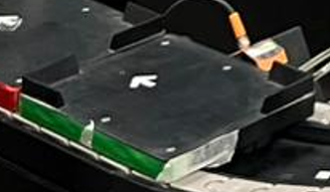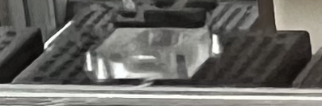

Cart Pallet

Station 1 - Storage:

The **Automated Storage Retrieval System (ASRS) 2** simulates a real-world automated warehouse system, allowing students to learn how modern factories manage storage and logistics without manual labor.

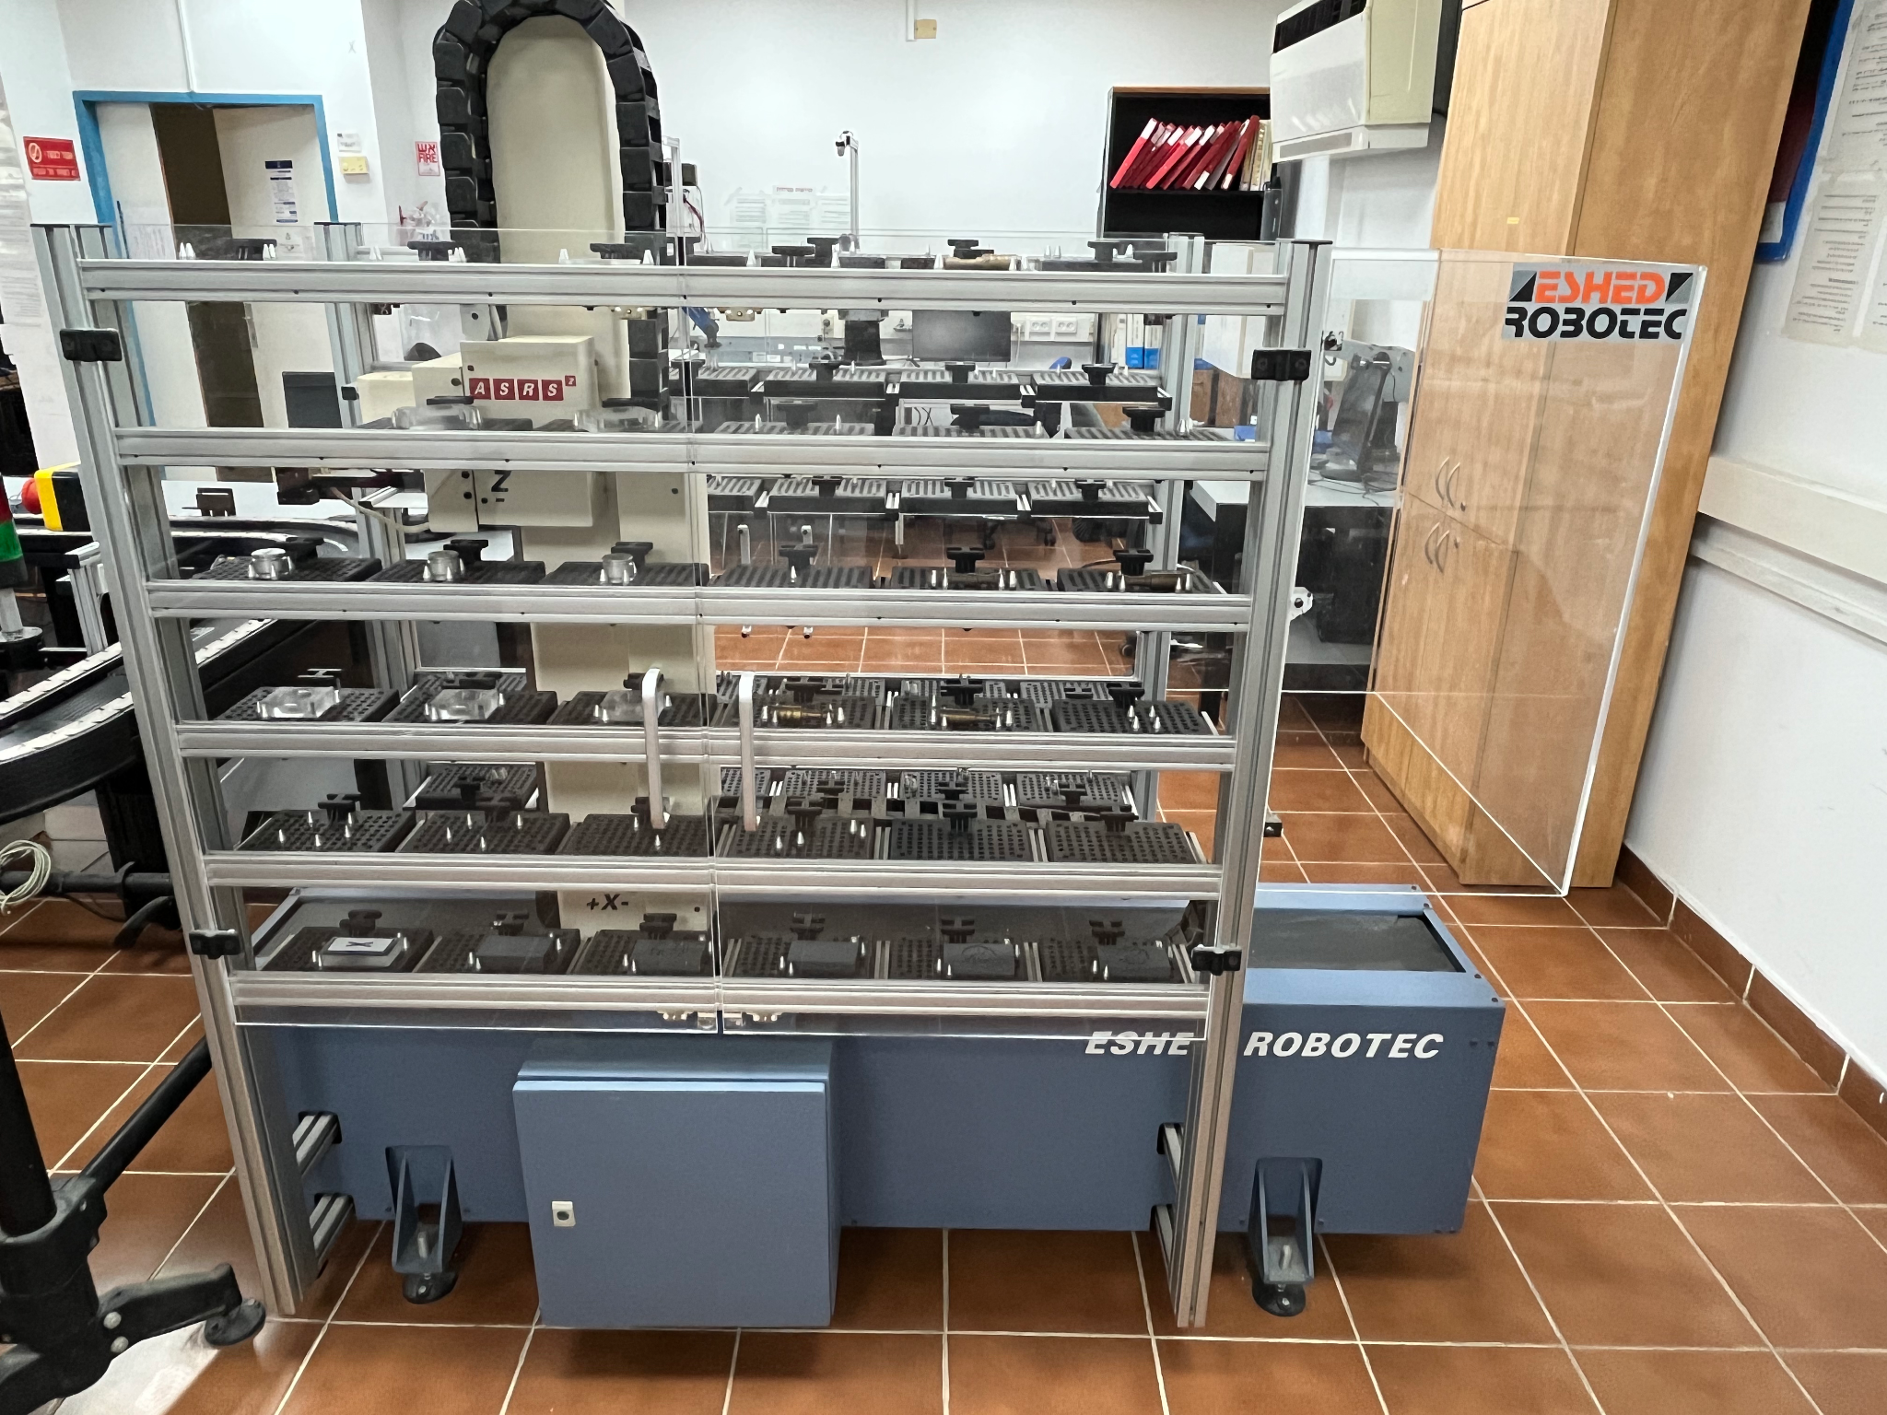.  
ASRS 2 in Lab D106

Station 2 - Creation:

The **BenchMill 6000** is a training Computer Numerical Control (CNC) milling machine used to teach and demonstrate automated precision machining.

The **SCORBOT-ER V Plus** is a robotic arm responsible for retrieving the pallet from the cart at the conveyor belt and placing it in the designated working area.

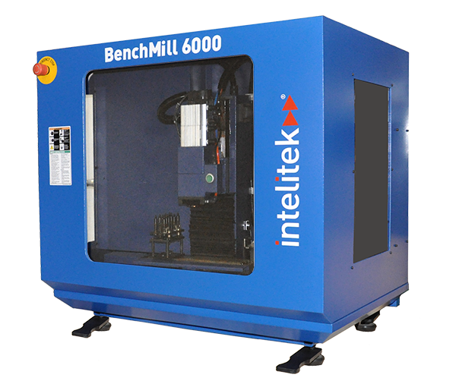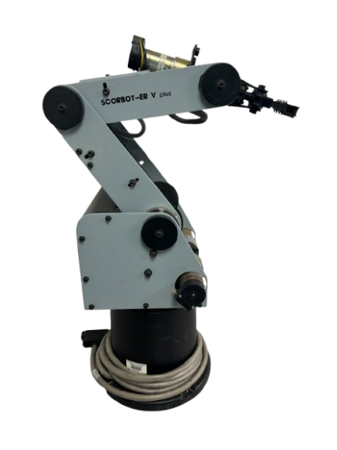

BenchMill 6000 SCORBOT-ER V Plus

Station 3 - Review:

The review station is operated by a **Yaskawa Motoman** robotic arm, which transfers each part to the inspection area. There, a moving pallet positions the item under a camera for quality assessment. If the part is marked with an "X", it is discarded; if marked with a "✓" it is returned to the cart within the CIM system.

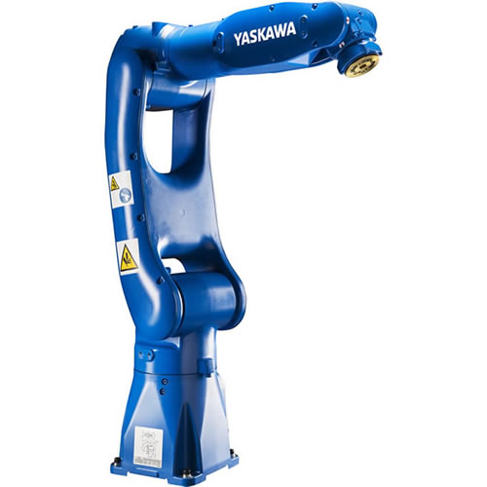

Yaskawa Motoman-GP8

Station 4 - Assembly:

The **SCORA ER-14** is responsible for completing two distinct assembly plans. (I) In the first plan, a cylindrical component is precisely inserted into a rectangular part that features a pre-drilled hole, ensuring a secure and accurate fit. This task requires alignment precision and steady handling. (II) The second plan involves assembling a children’s game by placing marbles into a hollow plastic body. Once filled, a cover is positioned on top and secured in place using pins, completing the interactive toy. Both tasks at Station 4 emphasize careful manual assembly and attention to detail to ensure functional and safe final products.

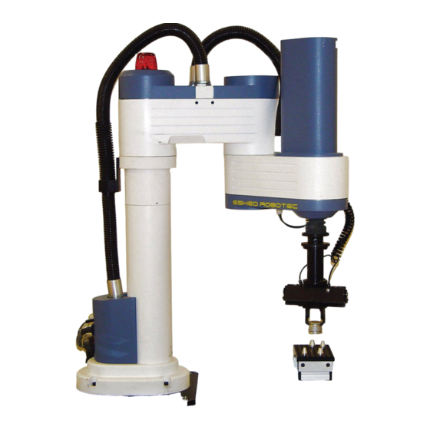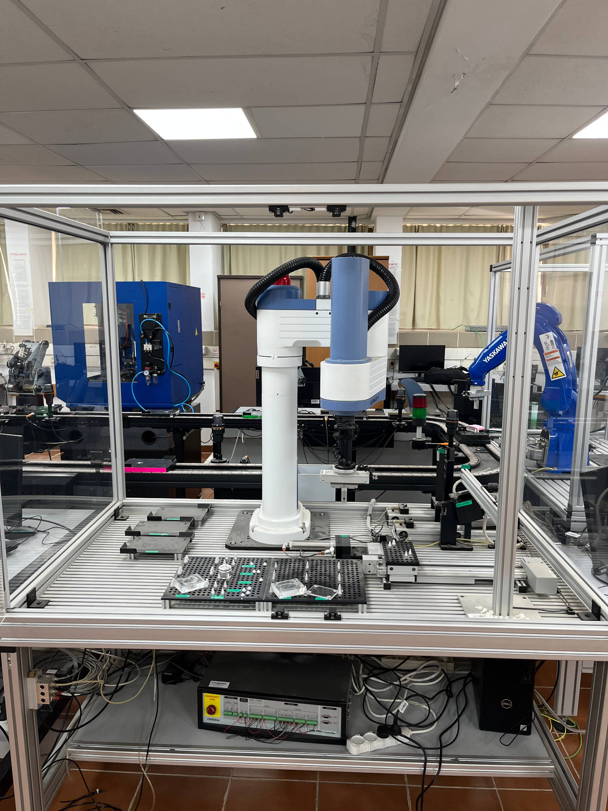SCORA-ER 14 Components

M5 Stack Controller and QR-CODE Sensors

An **M5 Stack** controller is connected to a PaHub splitter, which is linked to four QR code sensors—one at each station. Each station is equipped with a **QR-CODE TRIG** sensor mounted on a stand, used to scan the QR code sticker on the cart to confirm its arrival at the station.

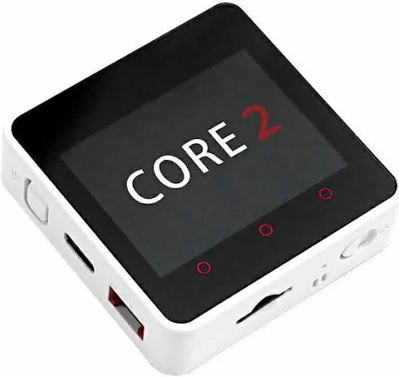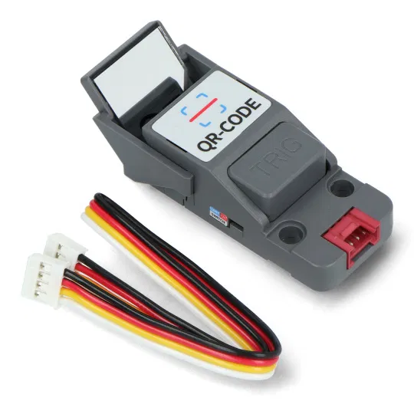

M5 Stack QR-CODE TRIG

# 3. Engineering Process

## 3.1 - Timeline

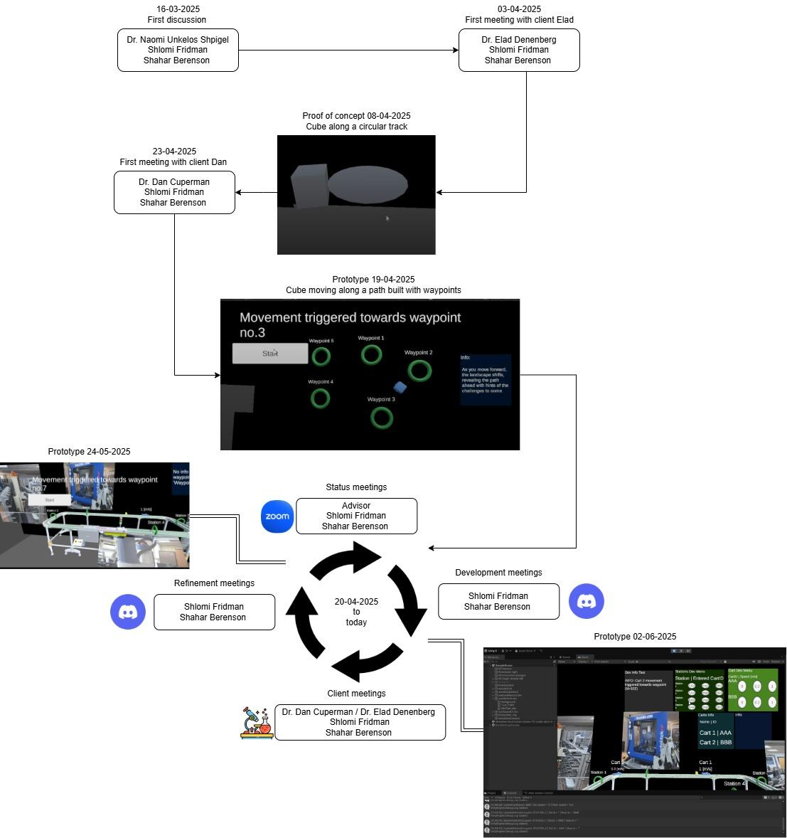

## 

## 3.3 - Interviews

During the development of the application, weekly interviews were held to better understand and assess the project’s requirements. These interviews helped guide the work by providing feedback and clarifying the needs of the users. Key interviews were summarized to keep track of important points and decisions. This regular communication helped ensure the application stayed on the right path and met its goals.

**Interview with the Dr. Dan Cuperman (Client)**

April 23rd, 2025 at Lab D106 13:45-14:38;53:03

In the preliminary interview conducted as part of the project’s research phase, we discussed with the client, Dr. Dan Cuperman, about the conceptual framework and technical aspirations for an AR application, designed to support a production line with monitoring and as an educational tool to be used to teach new engineering students. In the interview we discussed the project's objectives and goals, particularly the development of a DT that visualizes the operational status and flow of activity within the production process. Through the interview, we examined the potential scope and complexity of the application, aligning expectations with practical development capabilities. The interview also helped clarify the intended user experience and technological constraints, laying the groundwork for subsequent design decisions and system architecture for our project.

**Interview with Daniel Wasserman (Laboratory Engineer)**

May 4th, 2025 at Lab D106 13:00-13:32;32:17

In this interview, we met with Daniel, the laboratory engineer overseeing the production line system in D106. We discussed the system's operational aspects, including its movement and how products are processed at various points. Daniel confirmed a quality control process for defective products and expressed openness to assist us with data or footage. He acknowledged the potential of our proposed AR-based DT application for remote system monitoring and as an educational tool, and emphasized the importance of understanding integrated engineering for modern projects.

**Interview with client Dr. Elad Denenberg (Client)**

May 7th, 2025 at Lab D106 9:05-9:27;22:16

We conducted a meeting with our client, Dr. Elad Denenberg, to further refine the application's requirements. The discussion focused on three main aspects: (I) Identifying and modeling the production line cart. (II) Integrating the DT model with real-time sensor data collected from various stations. (III) Determining the types of alerts or updates that should be displayed when desync arises between the virtual model and the cart's actual physical state.

## 3.4 - Software and Platforms Used in Development

**Project Tools**

* [**Draw.io**](http://draw.io) – Web-based diagramming tool for creating flowcharts, network diagrams, and system designs.
  + Used to create system and project diagrams.
* [**Notepad++**](https://notepad-plus-plus.org) – Open-source text and code editor for Windows.
  + Used to write and edit JSON configuration files.
* [**Ivrit.ai**](http://ivrit.ai) – An AI-based speech-to-text transcription service that supports Hebrew.
  + Used to transcribe interviews for research/documentation.
* [**Blender**](https://www.blender.org/) – Open-source 3D modeling and animation software.
  + Used to export and edit 3D models in .fbx format.
* [**Discord**](https://discord.com/) – A communication platform for text, voice, and video chat.
  + Used for internal team development meetings.
* [**Zoom**](https://www.zoom.com) – A video conferencing platform for remote communication and collaboration.
  + Used for meetings with the advisors.

**Client Application**

* [**Unity**](https://unity.com/) – A cross-platform game and AR/VR engine used to build interactive 2D, 3D, and XR applications.
  + Main engine used to develop the client application.
* [**Unity Cloud**](https://cloud.unity.com) – A suite of cloud services for Unity that includes version control, collaboration tools, and build automation.
  + Provides version control and collaboration for Unity projects.
* [**Visual Studio**](https://visualstudio.microsoft.com/) – An integrated development environment (IDE) by Microsoft for writing and debugging code in multiple languages, including C#.
  + Used to write and debug C# scripts for the Unity application.

**Server**

* [**Visual Studio Code**](https://code.visualstudio.com/) – A lightweight, open-source code editor with support for debugging, Git integration, and extensions.
  + Used to develop and manage server-side code.
* [**Postman**](https://www.postman.com/) – A platform for testing APIs by simulating HTTP requests and inspecting responses.
  + Used to test and simulate HTTP requests/responses from the server.
* [**Render**](https://render.com/) – A cloud platform for hosting web services and applications.
  + Platform used to deploy the server of the project.
* [**GitHub**](https://github.com/) – A web-based platform for version control and collaborative software development using Git.
  + Version control system for managing the server codebase.

**Sensor System**

* [**UIFlow**](https://uiflow2.m5stack.com/) – A visual programming environment designed for M5Stack microcontrollers.
  + Visual programming tool used to develop sensor scripts.
* [**M5Burner**](https://docs.m5stack.com/) – An official utility for flashing firmware and configuring Wi-Fi settings on M5Stack devices.
  + Tool used to configure and flash WiFi settings onto the M5Stack controller.

# 

# 4. Product details

## 4.1 Product Scope

The application provides a real-time, interactive 3D AR visualization of a production line. Features include QR-Code sensors based cart tracking, station information display, and touchscreen user interaction.

## 4.32 Product Value

-This app supports educational and operational use. It simplifies complex technical concepts for students through engaging AR, and offers lecturers real-time monitoring and teaching assistance.

## 4.23 Intended Audience

* **Engineering Students:** To explore AR-based representations of production processes and enhance their understanding of automation systems.
* **Lecturers**  **\ Lab-Staff :** To monitor cart movement and station activities, and to use the app during teaching sessions.

## 4.34 Intended Use

* **Students:** Learning tool to visualize production line operations in AR.
* **Lecturers:** Real-time teaching aid and monitoring tool during lessons.

## 4.65 General Description

The app anchors a virtual production line in AR space, visualizing stations, carts, and their movements. It integrates with physical QR-Code sensors and updates from a backend server to reflect real-time data.

## 

## 4.46 Functional Requirements

**AR Visualization:**

* Anchor the production line in physical space.
* Render 3D models for carts and representation of the stations.
* Show cart movement along predefined waypoints.

**Station Interaction:**

* Tap a station to view its description, image, or video.
* Each station includes a reader that sends updates to the server.

**Cart Information:**

* Each cart includes a speed reader that sends updates to the server.
* The cart’s speed is displayed above the cart, in meters per second.

**Tracking Logic:**

* Carts are tracked by ID and follow a waypoint path.
* An expected\predicted time is calculated for when a cart is expected at its next station.
* Alerts are displayed if a cart is late to a station.

**Server Sync:**

* The application client subscribes to updates and resyncs the AR display upon receiving changes.

## 4.7 External Interface Requirements

4.7.1 User Interface Requirements

* **AR View:**
* The medium through which users can visualize and interact with augmented reality elements overlaid on the real-world environment using AR tracking.
* **Station & Cart Display:**
* Interactive 3D models based on the real-world stations location in the production line.
* Overlay info:
  + Text Description - of the station, the cart’s movement speed, etc
  + Media - Images of the real-world stations, demonstration videos, etc.

4.7.2 Hardware Interface Requirements

* **Client Device:**
* **Camera Sensor:** Modern Android smartphone (Sony/SamSung/OmniVision/etc) camera, which will be used for the AR environment mapping.
* **Touchscreen Sensor:** Standard smartphone touchscreen (Goodix/Synaptics/etc) that will allow the main interaction method.
* **Production Line:**
* **QR-Code (UART/I2C) Sensors:** Track cart presence at a station by scanning QR-Code/Barcode.
* **Built-In IMU Sensors inside Controller M5StickC Plus2:** Track cart’s acceleration along the production line.

4.7.3 Software Interface Requirements

* **Backend API:**
* Subscription service that provides subscribers with real-time updates. e.g. cart’s speed, and station data.
* Simulation service that provides the data required for a simulation on the client’s end.
* Recording service that when enabled will record incoming messages from the production line, to be used for analytics and simulations.
* **AR SDK:**
* The XR Interaction Toolkit is a Unity framework used to render AR content and enable user interaction with virtual objects through gestures, touch, or tracked input within augmented reality experiences. It provides us with an extensive set of tools for development purposes.

4.7.4 Communication Interface Requirements

**Server to Application Client:**

**Protocol:** HTTP/HTTPS

**Data Structure Includes**:

* Cart data list
* Station occupants list
* UNIX timestamp

**Description**: The message is sent from the server to clients subscribed to the System-Update service. It contains real-time data enabling the client application to synchronize the virtual environment with the current state of the physical system.

**QR-Code Sensor to Server:**

**Protocol:** MQTT

**Data Structure Includes**:

* Station id
* Occupant id
* UNIX timestamp

**Description**: The message is sent from the QR-Code sensor to the server via an MQTT broker. This data allows the server to track the occupant (or the absence thereof) at specific stations in real time.

**Cart Sensor to Server:**

**Protocol:** MQTT

**Data Structure Includes**:

* + Cart id
  + Cart’s speed [m/s]
  + UNIX timestamp

**Description**: The message is sent from the IMU sensor mounted on the cart to the server via an MQTT broker. This message enables the server to monitor cart movement and speed in real time.

## 

## 4.8 Non-Functional Requirements

4.8.1 Capacity

* The system needs to support the four existing stations in the production line, i.e. display descriptions, images, etc.

4.8.2 Compatibility

* Android 14 (API Level 34) or higher required.

4.8.3 Reliability

* Operate crash-free for at least 30 minutes under full load.
* Graceful recovery from server disconnection.

4.8.4 Scalability

* The system can handle a dynamic number of carts on the production line.

4.8.5 Usability

* Touchscreen-based intuitive UI.
* Visual aids and media for better comprehension.

4.8.6 Performance

* The QR-Code sensor sends an update whenever there is a change in the station occupancy.
* Speed data updated every 10ms.
* Prediction window accuracy: ±0.5 seconds.
* Each station has a representation in the StationEnum, station i will have value Station_%i.

# 

# 5. Diagrams

## 5.1 - Architecture Diagram

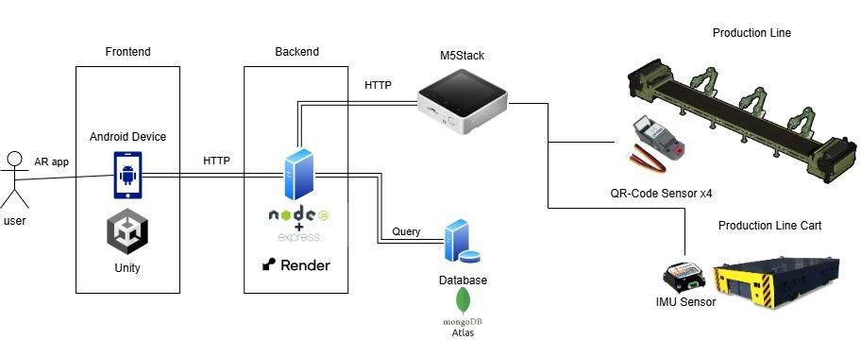

## 5.2 - Use Case Diagram

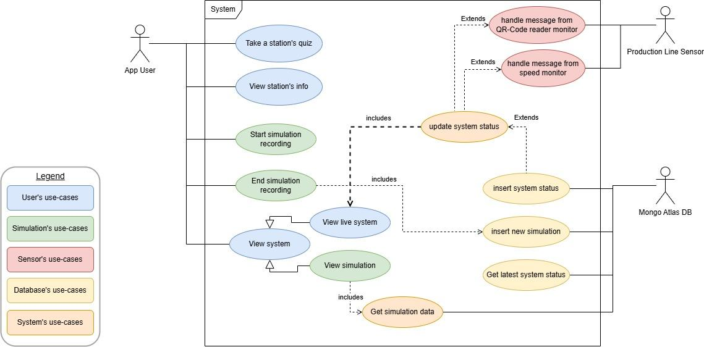

## 5.3 - Sensor Data Sequence Diagram

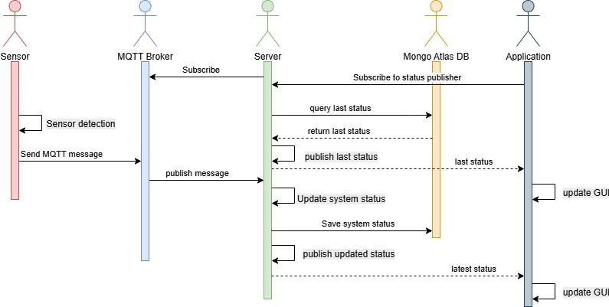

## 5.4 - Class Diagram

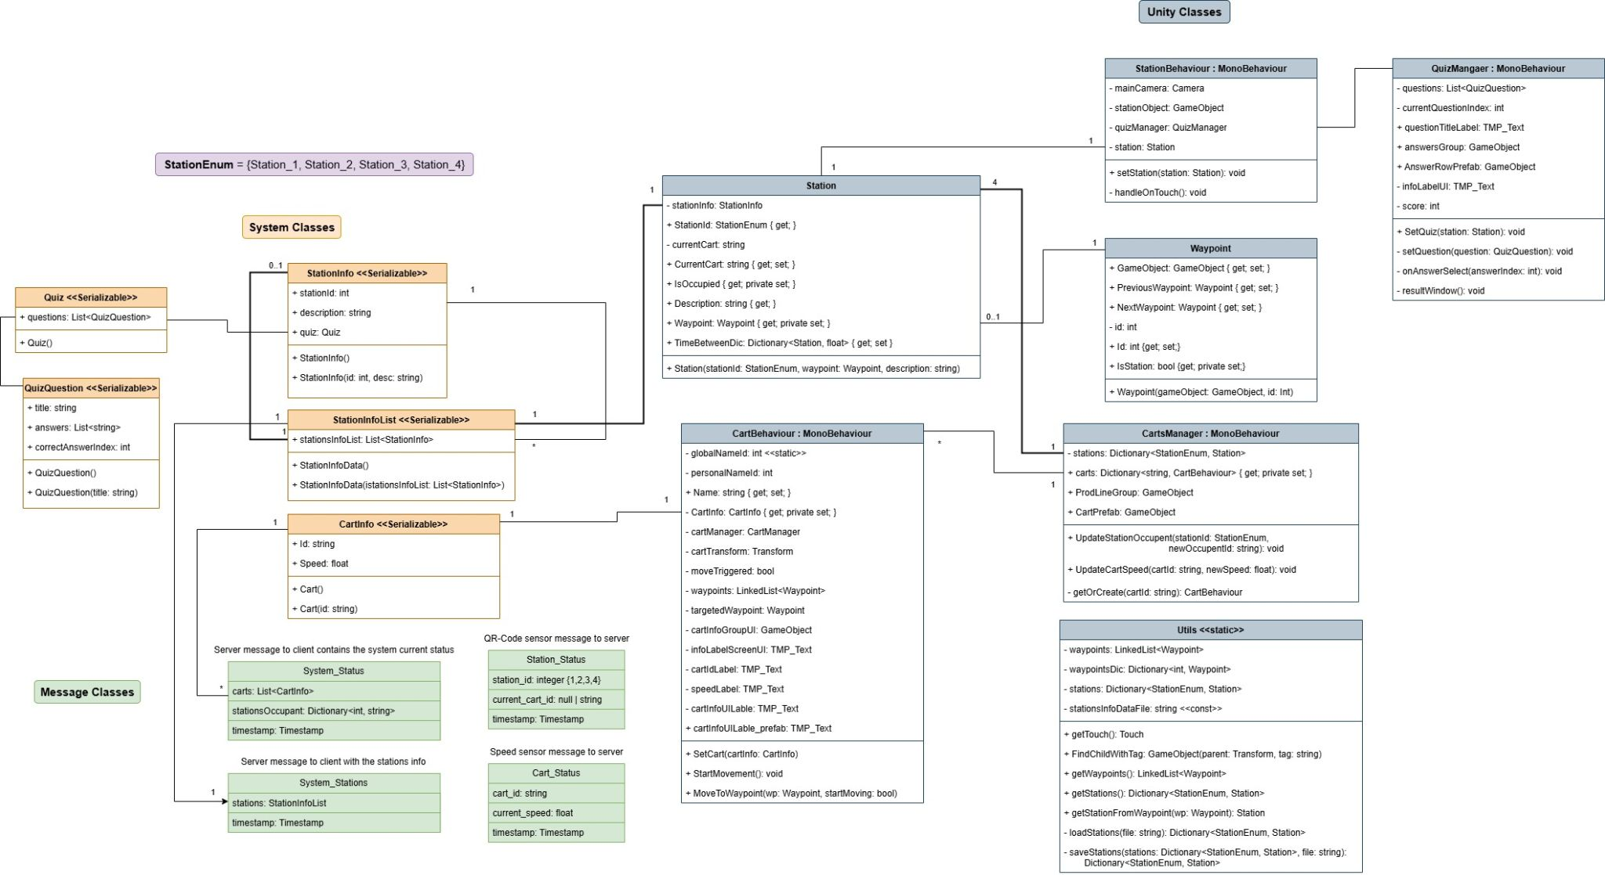



## 5.5 - QR-Code Sensor Flowchart

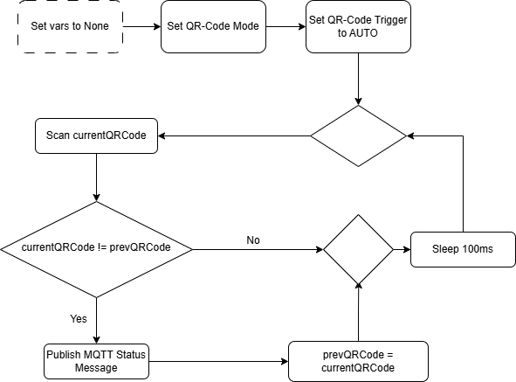

## 5.6 - IMU Sensor Flowchart

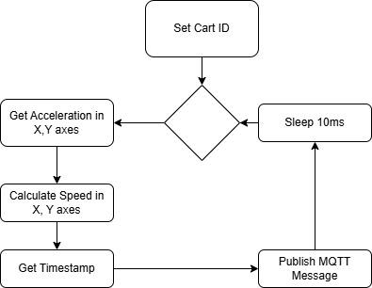

# 

# 6. Evaluation / Verification Plan

To ensure that we meet our goals for the augmented reality (AR) application for the Dan and Elad (lecturers at the machine engineering course). A plan has been established that outlines the expected achievements, the API metrics, and the structure of the prototype to be built.

## 6.1 - Expected Achievements

The primary outcome of this project is an augmented reality (AR) application deployed on the Vuforia platform. The application is designed to support two main user groups:

1. Lecturers \ Lab-Staff – The app will assist lecturers and staff in teaching and monitoring the production line by providing an interactive and visual representation of its real-time operation.
2. Students – The app will enhance students’ understanding of the production line by offering an immersive and detailed visualization of each station and the flow of carts throughout the process.

The AR application will display a live representation of the production line, track the progress of carts along it, and provide in-depth explanations for each station to facilitate both teaching and learning. Additionally, a simulation feature will allow users to view a previously recorded production line “loop,” enabling them to study its operation even in the absence of live data.

## 

## 6.2 - KPI Metrics

The success of the AR application will be evaluated based on the following Key Performance Indicators (KPIs):

* User Experience:
  + Users are able to effectively monitor the production line in real time through the application, with accurate station status within 100ms of the real-time change.
  + The predicted arrival time of a cart at any station is accurate within a margin of ±0.5 seconds.
* Performance:
  + The cart speed data is updated at intervals of 10 milliseconds.
  + The predicted arrival time of a cart at any station is accurate within a margin of ±0.5 seconds.
* Availability & Reliability:
  + The application is compatible with Android devices running version 15 or higher.
  + The application remains stable and does not crash during continuous use for at least 30 minutes.
  + The application is capable of handling temporary server connection losses without crashing or losing data integrity, and reconnects to the server within 1 minute after the crash.

## 

## 6.3 - Prototype

The prototype consists of an augmented reality (AR) application designed to visualize multiple carts moving through a production line. It displays each cart’s position, speed, and direction of movement within the AR environment. In addition, the application presents informative content for each production station, including descriptive text and relevant images to enhance user comprehension. To reinforce learning, the prototype also includes a brief quiz on each station.

6.3.1 Main Screens

* The production line and cart representations

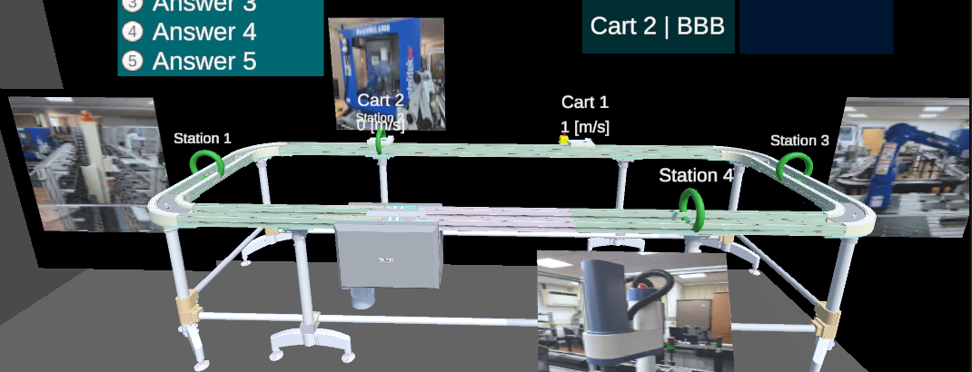

* Station quiz (proof of concept)

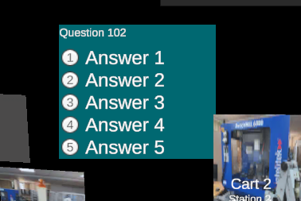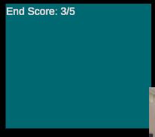

* Developer console and logging

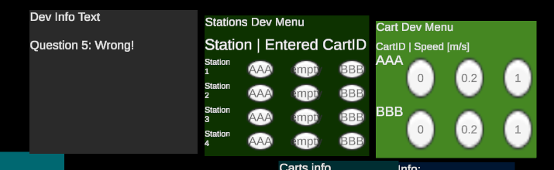

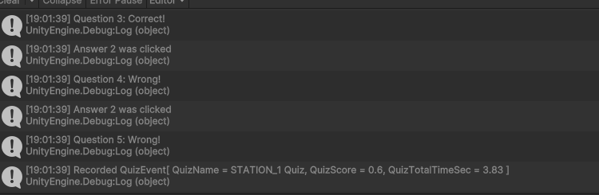

6.3.3 Testing

In the absence of a real server, we focused on two main tests designed to provide a believable simulation and validate the client application's logic flow.

* **Cart movement**:
  + Test: Is the cart movement an accurate representation of its real-world counterpart?
  + Result: The virtual cart's movement accurately simulates its real-world counterpart by following plotted waypoints on the virtual production line model.
* **Message handling**:
  + Test: Can the client application effectively process simulated messages regarding cart speed and station occupancy?
  + Result: The prototype logic successfully handles the simulated messages, updating station statuses and cart movement speed with the provided data, thus creating a believable virtual environment.

6.3.3 Feedback

Our prototype received positive feedback from both our client, Dr. Dan Cuperman, and our advisor, Dr. Naomi Unkelos Shpigel. They provided valuable suggestions, including the addition of a quiz (which we've already added as a proof-of-concept) and more refined cart models, which we plan to implement in a future version.

# References

# TODO sort by A-Z, and rename the references by numbers

[[Morchid 2024](https://www.sciencedirect.com/science/article/pii/S2090447923003982)] Morchid, A., El Alami, R., Raezah, A. A., & Sabbar, Y. (2024). Applications of internet of things (IoT) and sensors technology to increase food security and agricultural Sustainability: Benefits and challenges. Ain Shams Engineering Journal, 15(3), 102509.

[[Li 2024](https://www.sciencedirect.com/science/article/pii/S0747563224002759)] Li, J., Zheng, X., Watanabe, I., & Ochiai, Y. (2024). A systematic review of digital transformation technologies in museum exhibition. *Computers in Human Behavior*, 108407.

[[Shabur 2024](https://link.springer.com/article/10.1007/s43621-024-00290-7)] Shabur, M. A. (2024). A comprehensive review on the impact of Industry 4.0 on the development of a sustainable environment. Discover Sustainability, 5(1), 97.

[[Pavanatto 2021](https://ieeexplore.ieee.org/abstract/document/9417776/)] Pavanatto, L., North, C., Bowman, D. A., Badea, C., & Stoakley, R. (2021, March). Do we still need physical monitors? an evaluation of the usability of ar virtual monitors for productivity work. In *2021 IEEE virtual reality and 3D user interfaces (VR)* (pp. 759-767). IEEE.

[[Peter 2023](https://www.sciencedirect.com/science/article/pii/S1877050922023602)] Peter, O., Pradhan, A., & Mbohwa, C. (2023). Industrial internet of things (IIoT): opportunities, challenges, and requirements in manufacturing businesses in emerging economies. Procedia Computer Science, 217, 856-865.

[[Syed 2022](https://www.mdpi.com/1424-8220/23/1/146)] Syed, T. A., Siddiqui, M. S., Abdullah, H. B., Jan, S., Namoun, A., Alzahrani, A., ... & Alkhodre, A. B. (2022). In-depth review of augmented reality: Tracking technologies, development tools, AR displays, collaborative AR, and security concerns. *Sensors*, *23*(1), 146.

[[Fuentes 2024](https://www.mdpi.com/2224-2708/13/4/39)] Fuentes-Peñailillo, F., Gutter, K., Vega, R., & Silva, G. C. (2024). Transformative technologies in digital agriculture: Leveraging Internet of Things, remote sensing, and artificial intelligence for smart crop management. *Journal of Sensor and Actuator Networks*, *13*(4), 39.

[[Bucsai 2020](https://ieeexplore.ieee.org/abstract/document/9039901/)] Bucsai, S., Kučera, E., Haffner, O., & Drahoš, P. (2020, January). Control and monitoring of IoT devices using mixed reality developed by unity engine. In 2020 Cybernetics & Informatics (K&I) (pp. 1-8). IEEE.

[[Liberty 2024](https://www.sciencedirect.com/science/article/abs/pii/S0260877423004910)] Liberty, J. T., Sun, S., Kucha, C., Adedeji, A. A., Agidi, G., & Ngadi, M. O. (2024). Augmented reality for food quality assessment: Bridging the physical and digital worlds. *Journal of Food Engineering*, *367*, 111893.

[[Wang 2024](https://www.sciencedirect.com/science/article/abs/pii/S0278612524000992)] Wang, B., Zheng, L., Wang, Y., Fang, W., & Wang, L. (2024). Towards the industry 5.0 frontier: Review and prospect of XR in product assembly. *Journal of Manufacturing Systems*, *74*, 777-811.

[[Yin 2023](https://www.sciencedirect.com/science/article/abs/pii/S0736584522001971)] Yin, Y., Zheng, P., Li, C., & Wang, L. (2023). A state-of-the-art survey on Augmented Reality-assisted Digital Twin for futuristic human-centric industry transformation. Robotics and Computer-Integrated Manufacturing, 81, 102515.

[[Diogo 2023](https://www.sciencedirect.com/science/article/abs/pii/B9780323992084000088)] Diogo, R. A., dos Santos, N., & Loures, E. D. F. R. (2023). Improving Brazilian Engineering Education: real engineering challenges in an IIoT undergraduate course. In Designing Smart Manufacturing Systems (pp. 35-57). Academic Press.

[[Al-Ansi 2023]](https://www.sciencedirect.com/science/article/pii/S2590291123001377) Al-Ansi, A. M., Jaboob, M., Garad, A., & Al-Ansi, A. (2023). Analyzing augmented reality (AR) and virtual reality (VR) recent development in education. Social Sciences & Humanities Open, 8(1), 100532.

[[Lin 2024](https://www.sciencedirect.com/science/article/pii/S1991790224003544)] Lin, P. Y., Chen, T. C., Lin, C. J., Huang, C. C., Tsai, Y. H., Tsai, Y. L., & Wang, C. Y. (2024). The use of augmented reality (AR) and virtual reality (VR) in dental surgery education and practice: A narrative review. Journal of Dental Sciences.

# Appendix

[Interview with Dan - 2025/04/23](https://drive.google.com/file/d/1nHimDMeTg4SHeiqRuvrjXWpqMoF7Axup/view?usp=drive_link)

[Interview with Daniel - 2025/05/04](https://drive.google.com/file/d/1nRq4u1tS71ARqqElQh8thitrDEGHeNk-/view?usp=drive_link)